Here is a comprehensive technical comparison across all three hosting options. I'll build this out section by section with supporting visuals.

Architecture overview
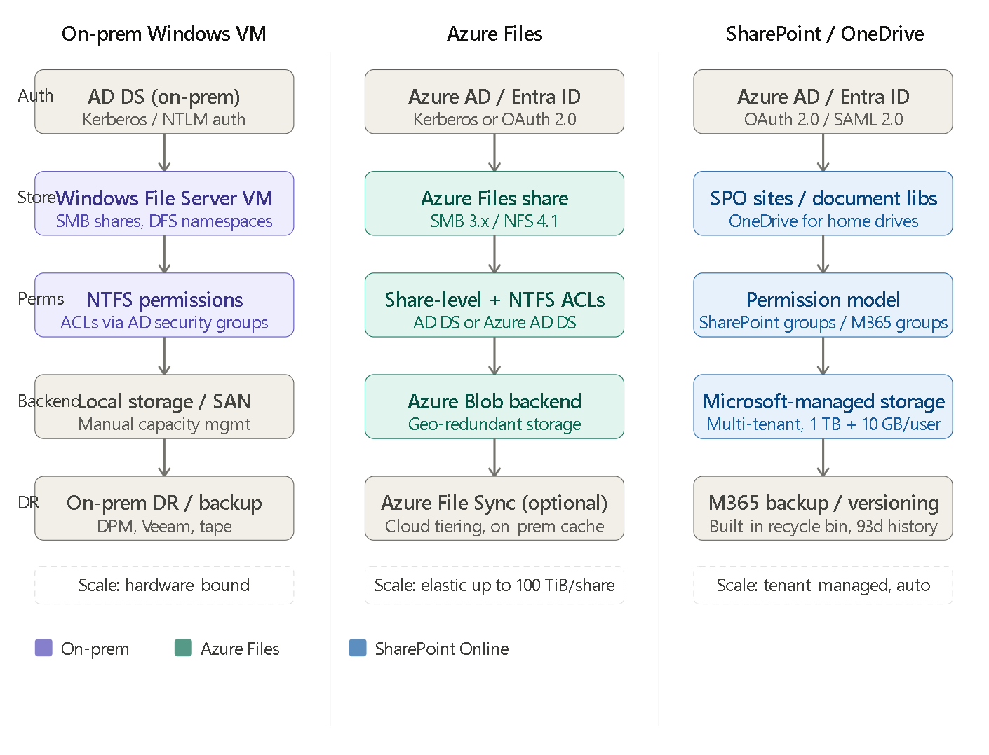
On-premises Windows VM operates with a traditional three-tier model: Active Directory Domain Services issues Kerberos tickets for authentication, Windows File Server VMs expose SMB shares (often organized under DFS namespaces), and NTFS ACLs enforced through AD security groups control access. Each VM is constrained by its provisioned storage and compute, and scalability requires procuring and provisioning additional hardware or SAN capacity. This model is well-understood, deeply familiar to IT teams, and requires no changes to user workflows or client configuration.
Azure Files is Microsoft's managed SMB/NFS file share service running on Azure Blob storage. It supports two identity integration modes: AD DS (joining the storage account to your on-premises domain via a Kerberos trust) or Azure Active Directory Domain Services (a managed domain controller in Azure). This allows NTFS-style ACLs to carry over with minimal rework. Standard tier uses HDD-backed storage billed on consumption; Premium tier uses SSD-backed storage billed on provisioned capacity and is suited for latency-sensitive workloads. Azure File Sync can optionally extend this by deploying a lightweight agent on on-prem Windows Server VMs, caching hot data locally while tiering cold data to the cloud — effectively providing a hybrid deployment mode.
SharePoint Online / OneDrive for Business is a collaboration-first platform hosted and managed entirely by Microsoft. It uses OAuth 2.0 via Azure AD, with a fundamentally different permission model: access is granted through SharePoint groups, Microsoft 365 groups, or direct sharing — not through classical NTFS ACLs applied to a file path hierarchy. OneDrive for Business acts as the personal drive replacement. This model is optimized for web-based collaboration, co-authoring, and integration with Teams and Microsoft 365 apps, but it diverges significantly from traditional file server access patterns.
Migration effort and complexity

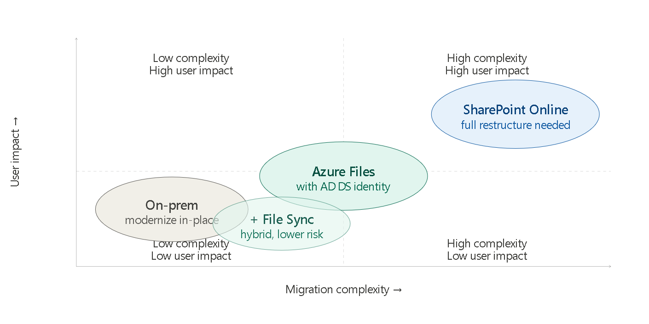

Remaining on-premises (modernize in-place): The lowest-friction option. Migration effort is limited to patching, storage upgrades, possible OS-version lifts (e.g., Server 2019 → 2022), and potentially adopting newer DFS-N or FSRM configurations. No data movement, no permission restructuring, no user retraining. Risks include continued technical debt accumulation, ongoing hardware refresh cycles, and the need to maintain DR infrastructure (backup agents, off-site replication). For environments spanning multiple child domains or separate forests, identity complexity already exists and is unchanged.
Azure Files: This is a lift-and-shift style migration with moderate complexity. The key steps are: (1) identity integration — registering your storage account against your on-prem AD DS or deploying Azure AD DS, (2) data transfer — using Azure Data Box or Robocopy/azcopy for initial seeding then incremental delta syncs, and (3) permission preservation — using tools like icacls export/import or the Azure File Sync agent, which handles ACL migration automatically. Azure File Sync is the recommended migration path for most organizations because it allows a phased approach: the sync agent caches data locally, users continue working with no disruption, and the org cuts over to pure-cloud access later. Identity is the biggest risk factor — multi-domain and multi-forest environments require careful SPN and trust configuration before Kerberos tickets can be issued against Azure Files.
SharePoint Online: The highest complexity migration path, because it requires a fundamental paradigm shift. Traditional file share hierarchies (deep folder trees, path-based access) do not map cleanly to SharePoint document libraries. Key challenges include: file path length limits (400 characters), blocked or restricted file types, metadata that must be mapped to SPO columns, permission flattening (NTFS inherited ACLs must be re-expressed as SharePoint permissions), and user behavior change (browser-based access, co-authoring model). Microsoft's SharePoint Migration Tool (SPMT) or third-party tools like Sharegate or Metalogix automate much of the data movement, but restructuring the information architecture requires significant planning effort. An AD-to-Azure-AD sync (Entra Connect) is a prerequisite.
Security and compliance comparison
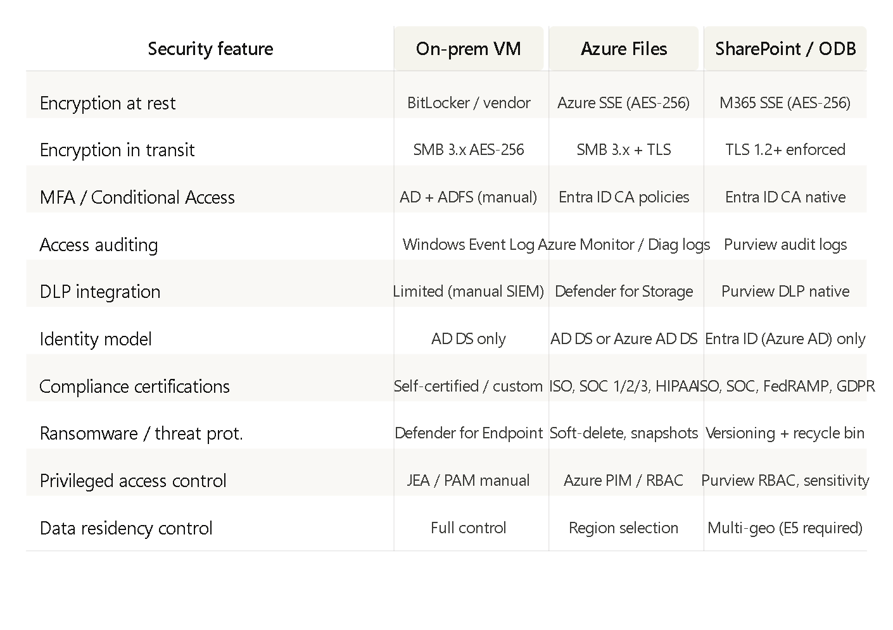
On-premises infrastructure gives the organization the most direct control over where data physically resides and how security tooling is configured, but this control comes at the cost of operational complexity. Every security layer — encryption, auditing, DLP, PAM — must be procured, deployed, and maintained independently. MFA and Conditional Access are achievable via ADFS with an MFA provider, but they lack the seamless integration that Entra ID-native policies provide.
Azure Files and SharePoint Online both benefit from Microsoft's shared security responsibility model and its extensive global compliance portfolio (ISO 27001, SOC 1/2/3, HIPAA, FedRAMP, and more). Azure Files gains Defender for Storage, which detects anomalous access patterns, malware uploads, and early ransomware indicators. SharePoint Online adds Microsoft Purview's native DLP engine, sensitivity labels, and unified audit logging — making it the strongest option for organizations with classification-heavy or regulated content workflows. The tradeoff is reduced control over infrastructure-layer security configuration.

Cost and operational model
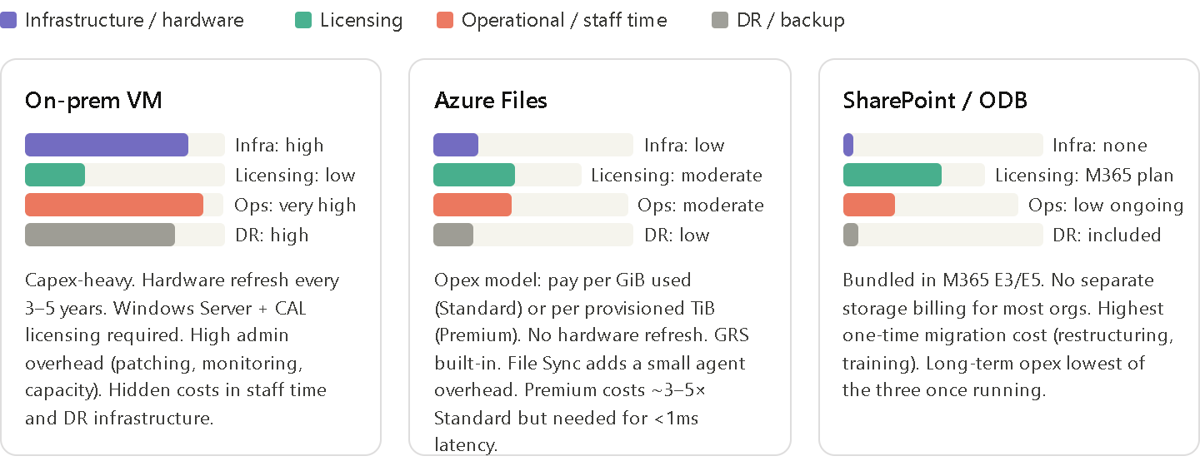
On-premises carries the heaviest total cost of ownership over a 5-year horizon, dominated by hardware amortization, Windows Server and CAL licensing, storage array or SAN costs, and the significant staff time required for patching, monitoring, and incident response. DR typically requires a second site or an off-site backup solution like DPM or Veeam with off-site replication, adding further cost. The apparent simplicity of "we own it" obscures a broad set of hidden operational costs.
Azure Files moves cost from capex to opex. Standard tier is billed per GiB consumed (roughly $0.06–0.08/GiB/month depending on redundancy tier) and suits cool/infrequently accessed data or large archival shares. Premium tier is provisioned in 100 GiB increments and billed per TiB/month ($0.26–0.30/TiB) — substantially more expensive but required when SMB latency under 1ms is needed. Geo-redundant storage (GRS or GZRS) replication is a configuration toggle rather than an infrastructure project. Azure File Sync itself incurs no additional license cost beyond the Azure subscription.
SharePoint Online / OneDrive for Business has essentially no incremental infrastructure cost for organizations already holding Microsoft 365 E3 or E5 licenses. Storage is included: 1 TB per tenant plus 10 GB per licensed user, with additional storage purchasable per GiB. The cost model shifts heavily toward one-time migration and adoption investment, but once in steady state, operational overhead is the lowest of the three options because Microsoft manages all infrastructure, patching, availability, and global DR.
Performance and workload fit
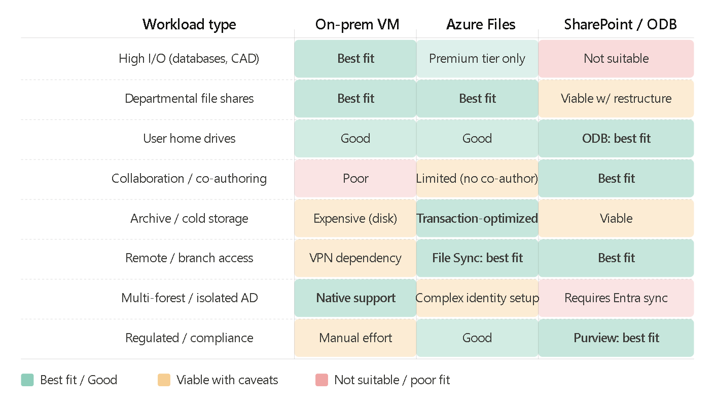
On-premises Windows VMs excel at workloads demanding predictable, sub-millisecond latency — line-of-business applications that open files locally (CAD, heavy ERP), SQL Server data files, and any application that embeds direct UNC paths in its code. They are also the natural choice when the AD environment is complex (multiple forests, cross-forest trusts, child domains with isolated GPOs) and you have no appetite for reworking identity architecture at this time.
Azure Files Standard suits departmental file shares, project storage, and moderately accessed data where latency in the 10–20ms range over ExpressRoute or 50–100ms over internet is acceptable. Azure Files Premium is required for workloads that demand consistent sub-millisecond I/O — virtual desktop infrastructure (FSLogix profile containers), databases, and high-throughput application data. Azure File Sync's cloud tiering feature makes it particularly effective for file servers with a large "long-tail" of infrequently accessed data: hot data stays cached on-prem, cold data lives in Azure and is recalled on demand transparently.
SharePoint Online should not be used as a direct SMB replacement for application data or anything requiring UNC path access. Its value is concentrated in document-centric, human-generated workloads: departmental collaboration spaces, intranet content, project documentation, and user home drives (via OneDrive for Business). The co-authoring capability in Word, Excel, and PowerPoint (via browser or desktop client) is a differentiator no other option provides.
Recommended scenarios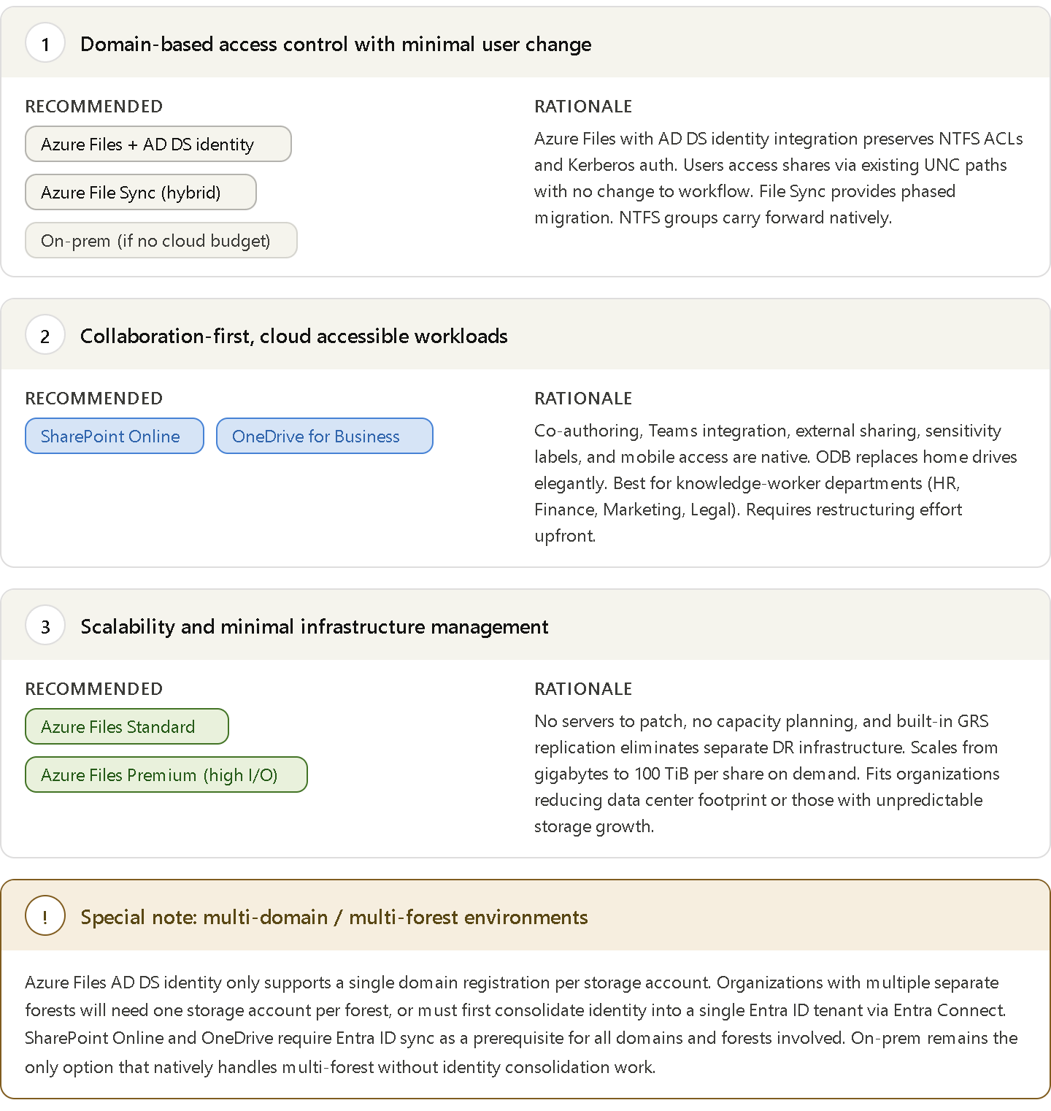

Consolidated comparison table
Dimension | On-prem Windows VM | Azure Files (Standard) | Azure Files (Premium) | SharePoint Online / ODB
Protocol | SMB 3.x, NFS | SMB 3.x, NFS 4.1 | SMB 3.x, NFS 4.1 | HTTPS / WebDAV
Auth mechanism | Kerberos (AD DS) | Kerberos (AD DS or Azure AD DS) | Kerberos (AD DS or Azure AD DS) | OAuth 2.0 (Entra ID)
NTFS ACL support | Native | Yes (via identity integration) | Yes (via identity integration) | No — SharePoint permission model
Max share size | Hardware-bound | 100 TiB/share | 100 TiB/share | 25 TB/library (SPO)
Latency | Sub-1ms (LAN) | 10–30ms (ExpressRoute) | Sub-1ms (ExpressRoute) | 50–200ms (internet)
Max IOPS | Hardware-bound | ~10,000 | Up to 100,000+ | Not applicable
Throughput | Hardware-bound | Up to 300 MiB/s | Up to 10 GiB/s | Not applicable
Co-authoring | No | No | No | Yes (native)
Built-in versioning | No (VSS snapshots) | Snapshots (manual/scheduled) | Snapshots | Yes (100–500 versions)
Built-in DLP | No | Defender for Storage | Defender for Storage | Purview DLP (native)
DR / backup | Manual (DPM/Veeam) | GRS / GZRS built-in | GRS / GZRS built-in | Microsoft-managed
Migration complexity | None (existing) | Medium | Medium | High
Ongoing ops burden | High | Low–Medium | Low–Medium | Low
Infrastructure cost | High (capex) | Low (opex/consumption) | Medium (opex/provisioned) | Zero (bundled in M365)
Multi-forest support | Native | One domain per SA | One domain per SA | Requires Entra sync

Summary guidance
For most enterprise organizations evaluating this decision, the right answer is almost never a single option applied uniformly across all workloads. The practical recommendation is a tiered approach:
Retain on-premises for workloads with hard latency requirements (sub-1ms I/O, application-embedded UNC paths, isolated-forest environments where identity consolidation is politically or technically infeasible in the near term). Accept that this carries ongoing infrastructure and staffing obligations.
Migrate to Azure Files for departmental file shares, project storage, and home drives where SMB semantics and AD-based access control must be preserved, but you want to eliminate hardware refresh cycles and improve DR posture. Use Azure File Sync as the migration mechanism — it is lower risk than a bulk cutover, allows transparent cloud tiering, and gives you a fallback path. Use Premium tier only where measured latency requirements justify the cost premium.
Migrate to SharePoint Online / OneDrive for knowledge-worker document stores, collaboration spaces, and user home drives — particularly in departments already using Teams and Microsoft 365 apps. Accept the restructuring effort as a one-time investment and leverage it as an opportunity to rationalize information architecture. This should be the default target for net-new document workloads and for workloads where the primary activity is human collaboration rather than application data access.
The multi-domain and multi-forest context described in your environment is the most important constraint to address before committing to any cloud path: both Azure Files and SharePoint Online require a well-functioning Entra ID tenant with properly synchronized identities as their foundation. Identity consolidation planning should therefore precede — or run in parallel with — the file server modernization program.

